Using Docker

Ganesh Palnitkar

Installing docker on Windows:
Working with Docker as container engine on Window platform can be enabled using docker desktop for desktop operating systems. Native container support is enabled in Windows 2016 later version and server 2019 and later version.
Installing docker on windows 2019 server:
Invoke-WebRequest -UseBasicParsing "https://raw.githubusercontent.com/microsoft/Windows-Containers/Main/helpful_tools/Install-DockerCE/install-docker-ce.ps1" -o install-docker-ce.ps1
.\install-docker-ce.ps1
Installing Docker on Linux:
https://docs.docker.com/engine/install/
Docker is a Client-server architecture application with Client as an API and server as the Docker Daemon.
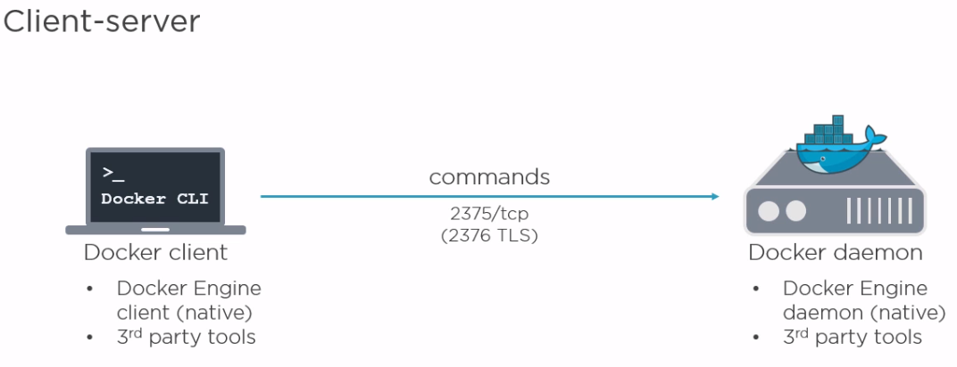
$ ls –l /run
This shows that the docker is running on the UNIX socket.
In order to make Docker run on TCP port run below command,
$ netstat –ntlp
This will show current programs listening on TCP ports.
Stop the docker service and restart it using below command to make it listen on a TCP port.
$ docker –H 192.168.33.35:2375 –d & …… in this command, we are making the service to start on TCP port in daemon mode.
This can also be set by editing docker.service
$ sudo systemctl edit docker.service
Add below text to the file,
[Service]
ExecStart=
ExecStart=/usr/bin/dockerd -H fd:// -H tcp://127.0.0.1:2375
Now, restart the Docker service,
$ systemctl daemon reload
$ systemctl restart docker
In order to connect to a docker host over TCP port from remote machine, set the environment variable on remote machine as,
export DOCKER_HOST=”tcp://192.168.33.35:2375”
This connects to the remote docker running on 192.168.33.35 machine.
To set it back to local Linux socket,
export DOCKER_HOST= … this will start listening docker back to local port.
We can also make the docker to run and listen on both Linux socket and TCP port.
$ docker –H 192.168.33.35:2375 –H unix:///var/run/docker.sock –d & … this will run docker on both ports.
Docker Images are used for launching docker containers.
$ docker run –it fedora /bin/bash
Interactive and terminal
Assign a shell
Image

$ docker pull –a <image name> , or,
$ docker pull <image name> … this will help in downloading image from docker registry.
We can view all available images on local machine, by using command,
$ docker images <image name> … this will list all downloaded images
Images are stored in Linux under /var/lib/docker/aufs (storage driver)
Docker Containers:
$ docker images …lists down all docker images available on the docker host machine.
We can exit container without killing the container by using keys ‘ctrl + P + Q’ …
Using these images docker creates and runs a container when we run the docker run command.
Image Layers:
A docker container is formed using multiple images stacked on each other.
Union mount system helps to mount multiple filesystem components on to each other.
R / W layer
Patches (Layer 3)
Nginx (Layer 2)
Base image (Root FS) (Layer 1)

$ docker history <image-id>… view of the image layers.
root@ubuntu-focal:/home/vagrant# docker history ganeshhp/tomcat:10.0.23
IMAGE CREATED CREATED BY SIZE COMMENT
d992c6e27a2d 10 months ago bash 571MB
<missing> 11 months ago /bin/sh -c #(nop) CMD ["bash"] 0B
<missing> 11 months ago /bin/sh -c #(nop) ADD file:396eeb65c8d737180… 77.8MB
$ docker history <image name> … this will also give detailed info about the docker images and layers.
Now try creating a new image from an existing container. First start a container with new changes, like,
$ docker run ubuntu /bin/bash -c "touch file1 | echo 'hello world' > file1"
Now run $ docker ps –a
Listing the container on the docker host can also be done using the command,
$ docker container ls --all --filter status=existed
$ docker rm $( docker container ls --all --filter STATUS=existed –format “{{ .ID }}”)
Run the command to create an image from the latest container.
$ docker commit <container id> <new-image name>
e.g.
$ docker commit d92a9d94aea8 newimage
This will create an image as ‘newimage’ and we can make use of this to create a new container.
The history command will give more info about the image layers.
$ docker history newimage
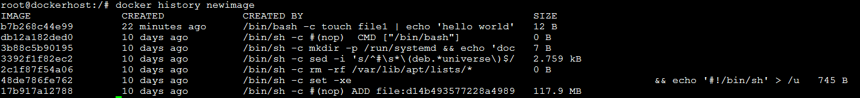
The layers shows above are the locked layers. When we use it to run a container it adds a writable layer which allows making changes to the files inside the locked layers.
Now to allow this image to be shared with others we can use below command. Export image..
docker save –o <location to save image> <image name>
$ docker save –o /tmp/newimage newimage
The image file is created as a tar file. Run tar command to check the file contents.
$ tar –tf newimage … this will show all layers and related file zipped in a the image file.
Now to make use of the newimage.tar image file. Import Image…
$ docker load -i newimage.tar …
$ docker images
Now use docker run command to make use of the image.
In most cases the container are run in the detached mode using the switch ‘–d’..
The docker run commands comes with lot of options, run $ docker run -–help to get more information about it.
IMP!!!! To get detailed information about a container, we can use command,
$ docker inspect <container-id>
Container Management
Docker Containers are started using docker run command. And can be stopped using docker stop <container-id>. A container can also be started using docker start <container-id>.
Docker container can also be stopped using command.
$ docker kill <container-id>
Docker container can be deleted using command,
$ docker rm <container-id>
The PID 1 always controls the docker container. When we kill the container we actually kill the PID 1.
!!! IMP !!! We can also use the docker exec -it <container-id> /bin/bash command to login to a running container and when we exit from the container shell, this does not kill the container.
We can use the $ docker top command to actually see all processes running inside the docker container.

Docker Hub
Public and Private repositories:
Account on the docker hub is similar to GITHUB account.
Add a tag to the existing image in order to push the image file to the Docker hub. This can be done as shown below.
$ docker tag <image-id> ganeshhp/helloworld:0.1.0
Once the image is tagged, we can then use the docker push command to push docker images to the remote docker repo.
$ docker push ganeshhp/helloworld:0.1.0
This will push only new layers of the images to the docker hub.
Docker registries can also be created on local server as private registries.
To create a local registry, run below command to spin a local docker registry.
$ docker run –d –p 5000:5000 registry …. This will run a container in daemon mode with the network port 5000 on local server mapped to the network port 5000 on public server.
So, we are actually going to start a container using the registry image on a local ubuntu server.
Once the container starts, we can access the registry at port 5000 on the container.
In order to push the local image to the registry, we will have to tag the image with the registry server identity, we shown below.
$ docker tag helloworld:0.1.0 localhost:5000/helloworld:0.1.0
Also, we will have to add a line in the daemon.json file inside /etc/docker with below details.
{ “insecure-registries”:[ “localhost:5000” ] }
Once the line added restart the docker daemon on the docker host.
Now, in order to get a list of available images in the docker image registry we have curl command to query and list the images.
$ curl localhost:5000/v2/_catalog
In this case, there’s a problem. We can not have the images stored in the container persistent. So, in order to make the docker images stored in the local registry as persistent, we have to map an external volume to the registry container. We can do that by running below command. Please note here the path inside the container to which we have mapped the external volume.
$ docker run -d \
-p 5000:5000 \
--restart always \
-v /data/images:/var/lib/registry \
registry:latest

Docker Volumes:
Docker volumes allow sharing data outside the container. This way containers can access data outside the container.
$ docker run –it –v /test-volume -–name=volcontainer ubuntu16.04 /bin/bash
CTRLPQ
Here, -v switch is used to specify the volume.
--name switch used to pass container name
Now try creating a container using above command and then run, the $ docker inspect command to see the volume folder on dockerhost.
This way we can share or move file from container to host machine.
Now this volume can be shared by other container as well. This is done by using option as --volumes-from=<container-name> switch.
$ docker run –it –volumes-from=volcontainer ubuntu /bin/bash
Once the container is started in interactive mode, check the file system for the volume folder.
This way we can map the volume from outside the container to the file system inside a container.
We can also map a folder from the host to a container . this can be done at the time of starting a container by running the command,
$ docker run –it –v /data:/data ubuntu /bin/bash …. This will create a folder if not present already on the host machine and map contents of it into the container. A file folder placed inside the /data folder in the container are also made available outside the container.
The same can be done from writing the VOLUME /data inside the Dockerfile as well. Only difference in this case is, the contents of the folder available on host machine are not mapped to the container, but vice-versa.
To delete the volume along with the container we have to use the –v switch with docker rm command as shown below,
$ docker rm –v <container-id>

Dockerfile
Dockerfile is used for building docker image. The name of the file is specific and has to be that way.
Dockerfile is written in ‘plain text’, has a ‘simple format’ and has ‘instruction to build the docker image’.
Location of the Dockerfile is important.
Create a folder and a file inside it named as Dockerfile.
$ mkdir dockerproj.
$ cd dockerproj
$ nano Dockerfile
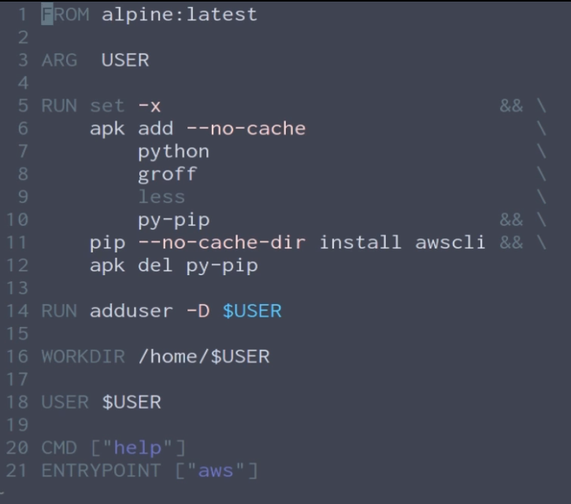
Value for variable ‘USER’ can be passed at RUN time.
Using declared variable in earlier statement
Define what gets executed at the time when container is built from image

Care to be taken while writing Dockerfile:
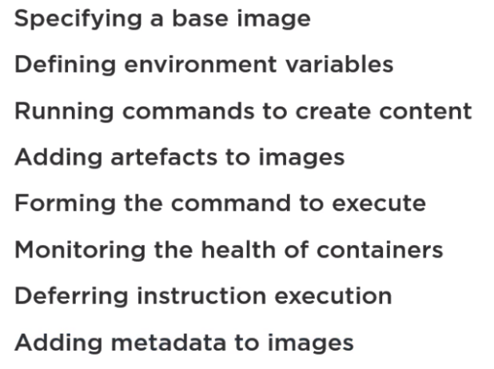

ARG instruction in Dockerfile:
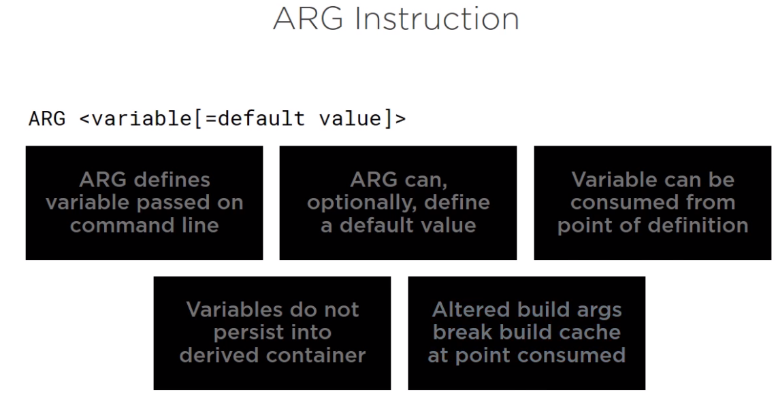
ENV instruction:
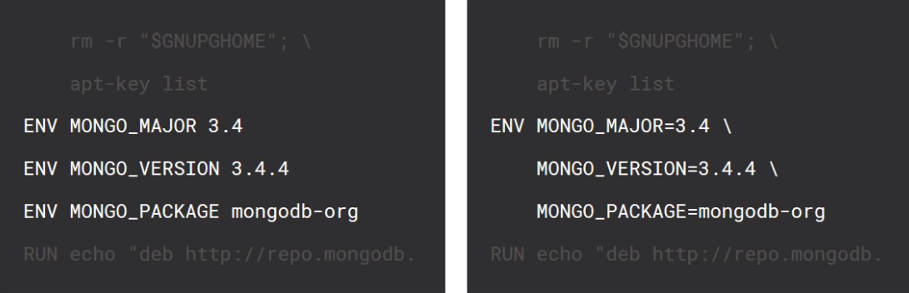
RUN Instruction:
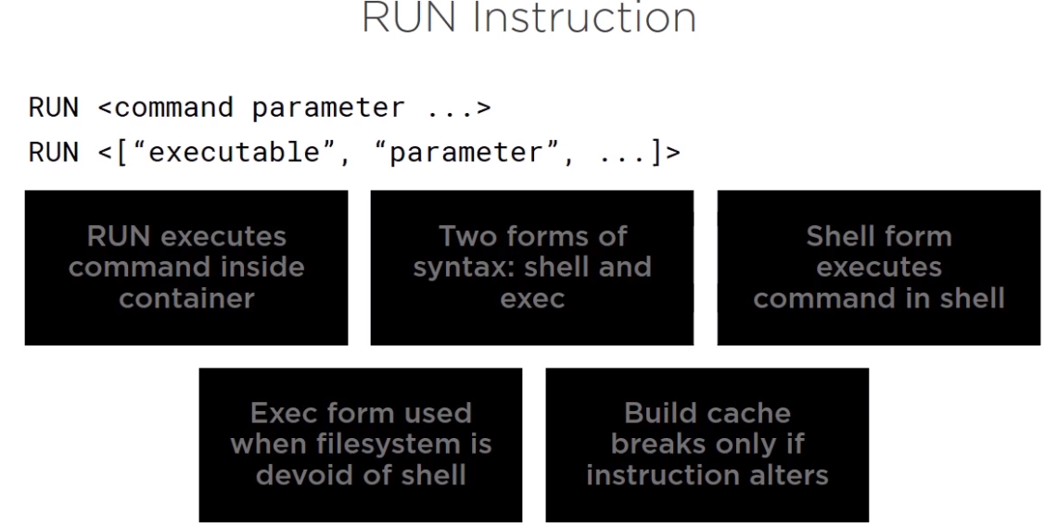

Copy Instruction:
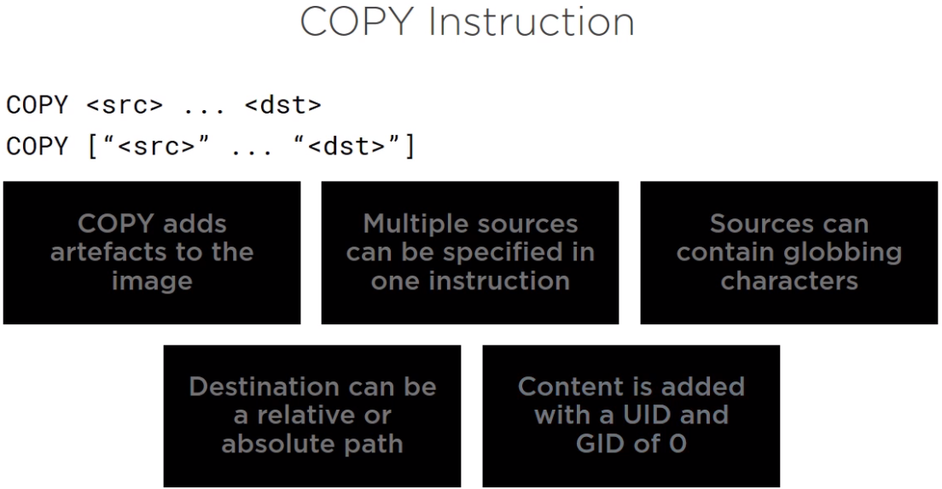
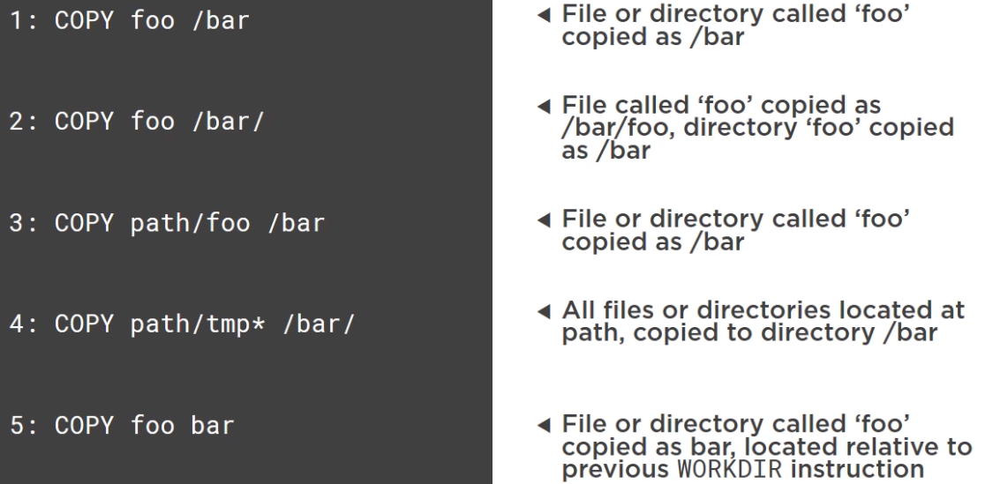
CMD Instruction:
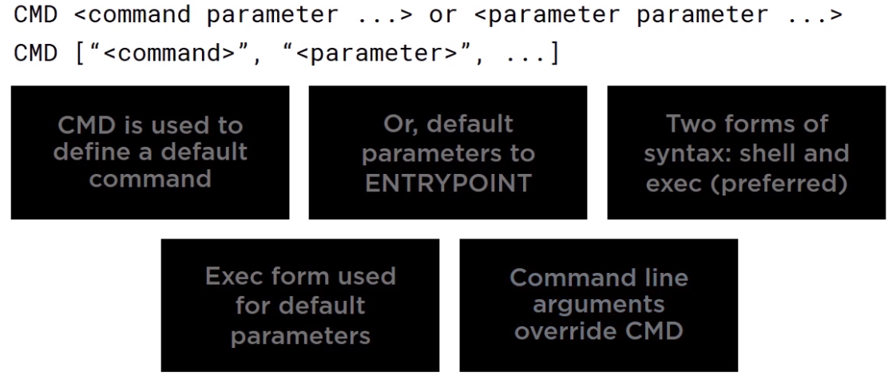

EXEC instruction:
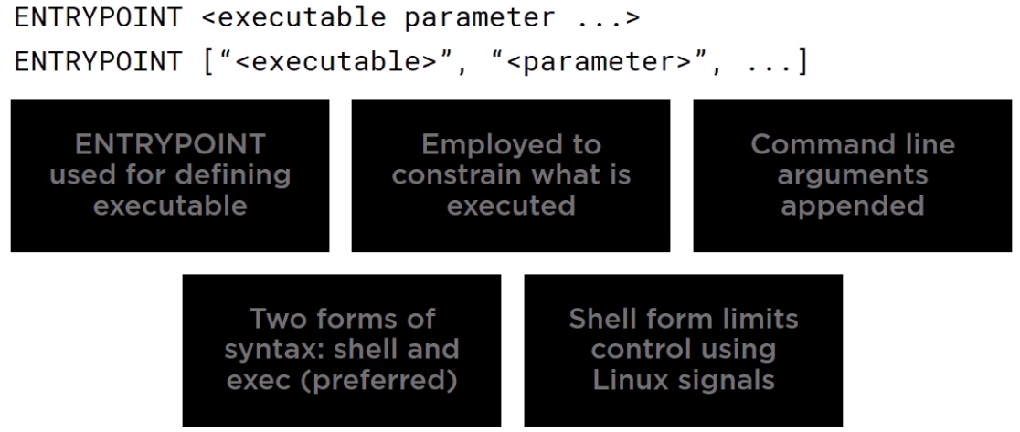

Below are the content of the Dockerfile
# ubuntubased container for a simple message.
# Each line starts with an instruction and its corresponding value.
FROM ubuntu:14.04
MAINTAINER ganesh@autofact.com
RUN apt-get update
# RUN apt-get install –y apache2
# RUN apt-get install –y ntp
CMD [“echo”,“Hello World”]

# RUN instructions are used to run commands against our images that we are building.
# Every RUN instruction adds a new layer in the image.

Difference between COPY and ADD instruction.
COPY and ADD are both Dockerfile instructions that serve similar purposes. They let you copy files from a specific location into a Docker image.
COPY takes in a src and destination. It only lets you copy in a local file or directory from your host (the machine building the Docker image) into the Docker image itself.
ADD lets you do that too, but it also supports 2 other sources. First, you can use a URL instead of a local file / directory. Secondly, you can extract a tar file from the source directly into the destination.
In most cases if you’re using a URL, you’re downloading a zip file and are then using the RUN command to extract it. However, you might as well just use RUN with curl instead of ADD here so you chain everything into 1 RUN command to make a smaller Docker image.

If we want to add any file inside the image, the file has to be present inside the folder where the Dockerfile is located.
To add a file to the image use the ADD instruction.
Use below command to create the image using Dockerfile.
$ docker build –t helloworld:0.1.0 . – here ‘helloworld’ is the image name, ‘0.1.0’ is the tag or version number and a ‘.’ at the end is for specifying the Dockerfile is located in the same folder from where we are running the command.
The name of the image has to be in lowercase characters.
Once the image build is ready, we can use the image to run the container using the docker run command.
Each instruction is going to add an image layer to the image that we want to create.
One more Dockerfile
#running a webserver in container
FROM ubuntu
MAINTAINER ganesh@autofact.com
RUN apt-get update
RUN apt-get install –y apache2
RUN apt-get install –y apache2-utils
EXPOSE 80
CMD [“apachectl”, “-D”, “FOREGROUND”]
To create an image from the Dockerfile, use below command.
$ docker build –t=”webserver” . --- here webserver is the image tag.
To test the container, we can run the image created using the Dockerfile.
$ docker run –d –p 80:80 <webserver> …. This will run the container and start the Apache webserver on it.
How to reduce number of images in such case?
For this we can reduce the number of instructions. So the Dockerfile would look like as shown below,
FROM ubuntu
MAINTAINER ganesh@autofact.com
RUN apt-get update && apt-get install –y
apache2 \
Build time instruction
apache2-utils \
&& apt-get clean \
&& rm –rf /var/lib/apt/lists/* /tmp/* /var/tmp/*
EXPOSE 80
Run time instruction
CMD [“apache2ctl”, “-D”, “FOREGROUND”]
This will help reducing the number of layers as well as the size of image.
CMD instruction is a runtime instruction, whereas RUN is a build time instruction. There can only be one CMD instruction in one Dockerfile.
Build Cache:
When we create docker container using a Dockerfile, docker daemon saved the action in build cache and when we run the same instructions, it will use the information from cache and save the time to download or install everything again.
Try creating a docker container from a Dockerfile and rerun the docker build command again and note the difference.
Dockerfile and Layers:
Each instruction adds a layer to the docker image. In order to reduce number of layers in the image we can pack some of instructions in a single instruction.
Multistage Dockerfile
A multistage Dockerfile is a Dockerfile that uses multiple stages to build and optimize a Docker image. It allows developers to create smaller and more efficient Docker images by separating the build environment from the runtime environment, and only including the necessary files in the final image.
Here's an example of a multistage Dockerfile:
# Build stage
FROM node:14-alpine as build
WORKDIR /app
COPY package*.json ./
RUN npm install
COPY . .
RUN npm run build

# Run stage
FROM node:14-alpine
WORKDIR /app
COPY --from=build /app/package*.json ./
RUN npm install --only=production
COPY --from=build /app/dist .
CMD ["node", "server.js"]

This Dockerfile has two stages: the build stage and the run stage.
In the build stage, the Docker image uses the node:14-alpine base image and sets up a working directory at /app. It then copies the package*.json files to the working directory, installs the dependencies with npm install, copies the rest of the files to the working directory, and builds the application with npm run build.
In the run stage, the Docker image again uses the node:14-alpine base image and sets up a working directory at /app. It then copies only the necessary files from the build stage to the working directory, installs only the production dependencies with npm install --only=production, and copies the dist directory (which contains the built application) from the build stage to the working directory. Finally, it sets the default command to run the server with node server.js.
By using a multistage Dockerfile, this image is optimized to only include the necessary files and dependencies for running the application, resulting in a smaller and more efficient image.

Docker Networking
To understand how containers are created with a network IP address automatically, let’s run the ifconfig on the host. Here we see that there’s a docker0 adaptor (n/w switch) running which manage the host to container network.
# in Docker environment on the docker host, there’s always a default bridge network. We can list all networks on the host by using command,
$ docker network ls
NETWORK ID NAME DRIVER SCOPE
f71a95282ed0 bridge bridge local
cc1302596540 host host local
011a0c94a404 none null local
# to create a new custom network bridge interface, we can use command,
$ docker network create -d bridge mynetwork
# to create a container inside a specific network, use command,
$ docker run –dt --net=mynetwork --name=generic ubuntu:latest
Now, to get details about the interface / switch we can install the below package.
$ apt-get install –y bridge-utils or on Centos,
$ yum install bridge-utils
The ‘bridge-utils’ helps to view and manage software bridge on the host machine.
Use $ brctl show command to see the components that the bridge is managing.
Here we have started two container and both are seen in the network bridge utility.
If we run traceroute command inside the container we can see the gateway used which in the dockerhost machine.
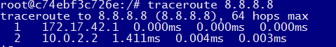
The network settings related file like, resolve.conf or hosts file for a container are available in the /var/lib/docker/container/<container-id> directory. We can make changes to the contents of these files in order to make the container alter network settings.
We can also expose network port on the container in the Dockerfile as we have earlier. Also at the run time we can map network port of host to a port on container by using below command.
$ docker run –it –p 5001:80 --name=webcontainer apache …By this we can map port on host to a port on container.
Or we can also use the IP address along with the port number as shown below,
$ docker run –it –p 192.168.33.35:5002 :80 –name=web1 apache
To view which ports are mapped on a container, we can use the command,
$ docker port <container-id>
In the Dockerfile we can expose multiple ports as show below,
EXPOSE 80 1001 1002 1004 1005
Build a new image from the Docker file
$ docker build –t=”sample” .
Use the image to create container,
$ docker run –d –P –name=samplecont sample
Now run command to view how ports are mapped to the host.
$ docker port sample.
All exposed ports are mapped randomly to ports on docker host
In order to assign a specific range of IP addresses for the containers, we can use below commands. First stop the docker daemon,
$ service docker stop
$ ip link del docker0 … remove the docker bridge
Edit the docker config file at /etc/default/docker and update the contents with,
DOCKER_OPTS=--bip=10.2.15.1/24 – this will assign the bridge IP address.
Restart the docker service. And see the docker bridge ip. This way we can assign a specific range of IP addresses to the docker bridge which inturn gets assigned to the container started .
Docker Firewall:
If we look at the iptables –L –v we see that there are defaults firewall setting about the docker container communication.
By default the --icc value is set to true which mean that all communications are allowed across all containers.
By setting the value to false we can disallow inter-container-communication to stop.
Also, by setting the –-iptables value to false, will disallow docker to interfere with iptables rules.
Update the file located at /etc/default/docker (docker conf file) with below line. DOCKER_OPTS=”—icc=true –iptables=false” …. The iptables rule overrides the icc settings.

Linking containers:
We can link two containers using few commands. Here we will create a container with a name as shown below,
$ docker run –d --name=src <image-name>
$ docker run --name=rcvr –link-src:src .. here link-src is the container name to which we want to link our ‘rcvr’ container. We also have to provide alias name for the src container.
Check the hosts file on the container and you will notice that the ipaddress of the src container gets added as an entry to the src alias name.

Log Maintenance:
Logs for docker daemon running on the docker host can be view as mentioned below. First stop the docker service and then run below command.
$ docker –d –l debug &
The docker file in the default directory in /etc can be updated to run the docker in required log level as show below.
DOCKER_OPTS="--log-level=fatal"
Some best practices in writing the Dockerfile.
- One would usually want to test each step inside a container before writing a Dockerfile that can be then used enterprise wide.

Docker Events:
Get real time events from the server.
Only the last 1000 log events are returned. You can use filters to further limit the number of events returned.
Docker containers report the following events:
- attach
- commit
- copy
- create
- destroy
- detach
- die
- exec_create
- exec_detach
- exec_die
- exec_start
- export
- health_status
- kill
- oom
- pause
- rename
- resize
- restart
- start
- stop
- top
- unpause
- update
Docker images report the following events:
- delete
- import
- load
- pull
- push
- save
- tag
- untag
Docker volumes report the following events:
- create
- destroy
- mount
- unmount
Docker networks report the following events:
- create
- connect
- destroy
- disconnect
- remove

